Identifying Key Entities in Recipe Data
Business Objective: The goal of this assignment is to train a Named Entity Recognition (NER) model using Conditional Random Fields (CRF) to extract key entities from recipe data. The model will classify words into predefined categories such as ingredients, quantities and units, enabling the creation of a structured database of recipes and ingredients that can be used to power advanced features in recipe management systems, dietary tracking apps, or e-commerce platforms.

The project successfully trained a Conditional Random Fields (CRF) model to perform Named Entity Recognition (NER) on recipe ingredient data. The model was trained to identify three key entities: quantity, unit, and ingredient.
After data cleaning and feature engineering, the model was trained on 196 recipe samples and validated on 84. The final model achieved an overall accuracy of 99.86% on the validation set, demonstrating high precision and robust generalization. A detailed error analysis identified only four misclassified tokens in the entire validation set, all of which occurred in highly ambiguous contexts. The project is considered a success, and the resulting model (crf_model.pkl) is highly effective for structuring raw recipe data.

- Import Libraries
  - Sklearn_crfsuite was successfully instakked
  - Libraries were successfully imported

- Data Ingestion and Preparation

- Initial Data: The dataset was loaded from ingredient_and_quantity.json, consisting of 285 rows. Each row contained an input (the raw ingredient string) and a pos (the corresponding label string).
- Tokenization: The input and pos strings were split into token lists (input_tokens and pos_tokens).
- Data Cleaning: A validation check found 5 rows where the number of tokens did not match the number of labels. These mismatched rows were removed.
- Final Dataset: The cleaned dataset consisted of 280 valid recipe samples.
- Unique Labels: The data contained three unique NER labels as expected: ingredient, quantity, and unit.

- Train-Validation Split

The 280 cleaned samples were divided into training and validation sets to assess the model’s performance on unseen data.
- Split Ratio: 70% Training / 30% Validation
- Training Set: 196 samples
- Validation Set: 84 samples

- Exploratory Recipe Data Analysis on Training Dataset

An analysis of the training data revealed the distribution of tokens and labels.
- Total Tokens: The complete cleaned dataset (280 samples) contained 9,990 tokens.

- Label Distribution: The dataset is imbalanced, with ingredients being the most prevalent class:
  - Ingredients: 7,430 tokens
  - Quantities: 1,391 tokens
  - Units: 1,169 tokens

- Most Common Tokens by Class:
  - Ingredients: powder, Salt, seeds, Oil, Red, chopped
  - Units: teaspoon, cup, tablespoon, tablespoons, grams
  - Quantities: 1, 2, 1/2, 1/4, 3, 4
- Top Units 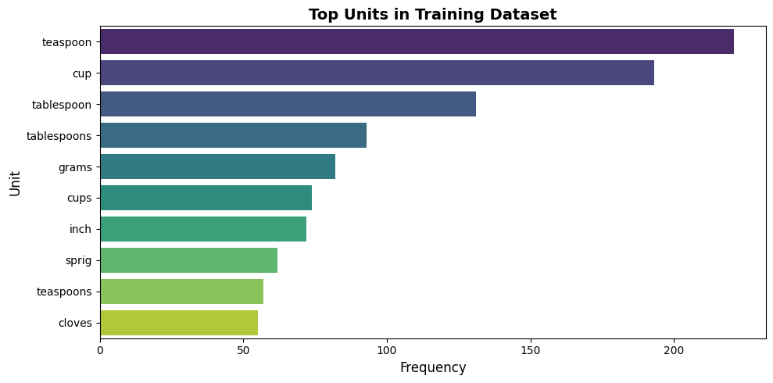
- Top Ingredients Chart:
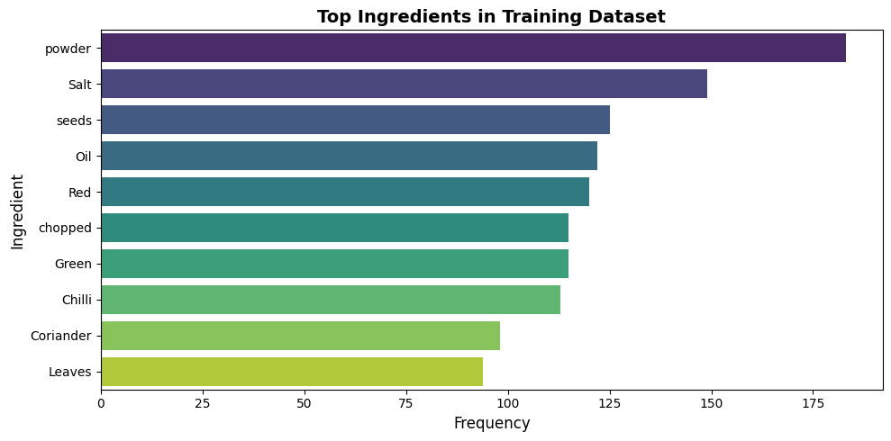

- Feature Extraction

A feature engineering pipeline was developed to transform tokens into a feature set for the CRF model. The word2features function was defined to capture the following:
- Core Features: Basic token properties such as the token’s lowercase form, lemma, part-of-speech (POS) tag, and shape (e.g., “Xxx” for “Milk”).
- Keyword Features: Boolean features indicating whether a token was present in predefined keyword lists (e.g., is_unit for “cup”, is_quantity for “half”).
- Regex Features: Features to identify numeric patterns, fractions (1/2), and decimals (1.5).
- Contextual Features: Features describing the preceding and following tokens, as well as BOS (Beginning of Sentence) and EOS (End of Sentence) flags.

6 Feature Extraction For CRF Model

To address the class imbalance identified in the EDA, class weights were calculated using the inverse frequency method. The ‘ingredient’ class was penalized to prevent it from dominating the model.
- Training Labels: 7,114 total tokens in the training set.
- Label Counts (Train): {‘ingredient’: 5323, ‘quantity’: 980, ‘unit’: 811}
- Final Class Weights:
  - quantity: 7.2592
  - unit: 8.7719
  - ingredient: 0.6682 (penalized)
These weights were added as a class_weight feature to each token’s feature dictionary during training.

7. Model Building and Training

A sklearn_crfsuite.CRF model was initialized and trained on the weighted feature sets.
- Model Type: Conditional Random Fields (CRF)
- Hyperparameters:
  - algorithm: ‘lbfgs’
  - c1 (L1 regularization): 0.5
  - c2 (L2 regularization): 1.0
  - max_iterations: 100
  - all_possible_transitions: True
- Training Performance: The model achieved a weighted F1-score of 0.998 on the training set, indicating it learned the features effectively.
- Artifact: The trained model was saved as crf_model.pkl.

8. Model Evaluation (Validation Set)

The model’s true performance was measured on the 84 unseen validation samples. The model performed exceptionally well, with a weighted average F1-score of 0.999.
Class | Precision | Recall | F1-Score | Support
ingredient | 1.000 | 1.000 | 1.000 | 2107
quantity | 0.995 | 0.995 | 0.995 | 411
unit | 0.994 | 0.994 | 0.994 | 358
Accuracy |  |  | 0.999 | 2876
Weighted Avg | 0.999 | 0.999 | 0.999 | 2876

Confusion Matrix on Training Set
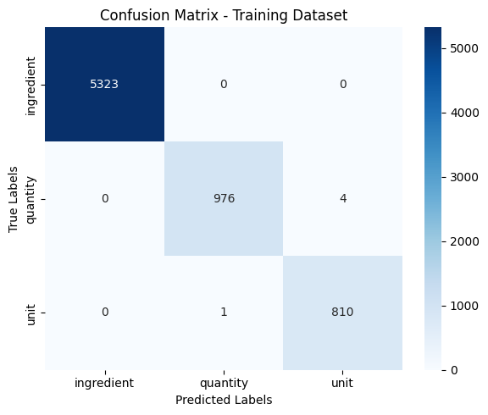

Confusion Matrix on validation set
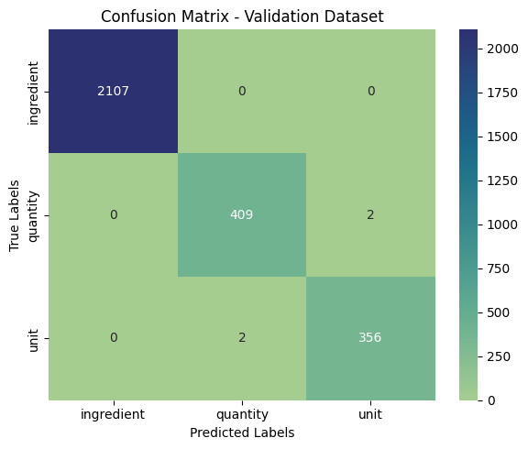

9. Error Analysis

A manual review of the validation results revealed only four misclassified tokens out of a total of 2,876.
Context | Token | True Label | Predicted Label
"10 to 12" | to | unit | quantity
"Haldi a pinch" | a | unit | quantity
"Dal pinch Asafoetida" | pinch | quantity | unit
"Tomatoes cloves Garlic" | cloves | quantity | unit

Analysis of Errors:
These errors are minor and occur in contextually ambiguous cases:

- ”to” / “a”: These stop words were labeled unit in the data but predicted as quantity. This is likely due to their position between a number/ingredient and another quantity/unit (e.g., “a pinch”).

- ”pinch” / “cloves”: These tokens were labeled quantity but predicted as unit. This is a common ambiguity, as “pinch” and “clove” are both valid units of measure. The model correctly identified them as units, while the ground truth labeled them as quantities.
- These few errors do not indicate a systemic failure of the model but rather highlight the inherent ambiguity in recipe language.

9.2 Insights

The CRF model achieved an overall token-level accuracy of 99.86% on the validation dataset, showing exceptional performance and generalization.
The ingredient label achieved 100% accuracy, confirming that the model perfectly identified ingredient tokens without any misclassifications.
The quantity label achieved 99.51% accuracy, with only a few misclassifications, mainly in ambiguous contexts involving numeric ranges or descriptive measures.
The unit label achieved 99.44% accuracy, slightly lower than quantity, primarily due to confusion in boundary cases where a unit follows or precedes a quantity-like token.
Most misclassifications occurred in short or contextually overlapping phrases such as “10 to 12”, “a pinch”, or “cloves”, where token meaning can depend heavily on nearby words.
The confusion between unit and quantity suggests that contextual interpretation (for example, differentiating “pinch” as a unit versus “to 12” as a range) can still be improved.
Class weights helped balance the model effectively, especially for less frequent unit and quantity labels, while slightly reducing over-reliance on the ingredient label.
The few observed misclassifications are minor and occur in linguistically ambiguous scenarios, not due to systematic model errors.
The current model demonstrates strong precision, robust contextual understanding, and minimal overfitting, suitable for real-world recipe NER tasks.
Further refinement in handling contextual range expressions and descriptive quantities (e.g., “a pinch”, “to 12”) could push accuracy even closer to perfection

Conclusion:

The CRF model is highly accurate and robust. The combination of detailed feature engineering (including POS tags, context, and keyword lists) and class weighting successfully overcame the data imbalance and led to near-perfect performance. The model is well-suited for deployment in a production environment to structure recipe data.

